|  |
| --- |
| Anvil v1.1 |
| User manual: Team Member |
| User documentation for the Anvil task management system. |



|  |  |  |
| --- | --- | --- |
| |  |  | | --- | --- | | |  | | --- | | Anvil is proudly brought to you by www.butternet.com  Butternet_1.png | | |

Table of Contents

[Introduction to Anvil 1](#_Toc293150498)

[Using the taskboard 2](#_Toc293150499)

[Selecting Project and release 2](#_Toc293150500)

[Drag and dropping tasks 3](#_Toc293150501)

[Adding a task 3](#_Toc293150502)

[Logout and Edit Details 3](#_Toc293150503)

[Managing impediments 4](#_Toc293150504)

[Using Anvil Support 5](#_Toc293150505)

[User documentation 5](#_Toc293150506)

[Logging a ticket 5](#_Toc293150507)

# Introduction to Anvil

Welcome to Anvil, the missing link to your development methodology. Anvil has been designed to fit perfectly with rapid development methodologies, but it can still be used with other, more “linear” methodologies.

Anvil allows a **team member** to do the following:

* Drag and drop tasks to change their status on a task board.
  + Tasks that are assigned to features in the selected project and release can be dragged and dropped to change their status. One of the following statuses: Not Started, Impeded, In Progress, Done.
  + Tasks can be added to a feature from here. This is for convenience, so that team members can add tasks as they come across them.
* Add impediments that may be holding a project up.
* Resolve any impediments that may be holding a project up.
* Access the Support tab
  + Download Team Member documentation.
  + Log a ticket with Anvil Support.

# Using the taskboard

You could say that the task board is the main feature of Anvil. The task board allows developers to track progress on tasks that need to be done for a specific feature. Many people like to use Post-it notes on a white board to track task progress, but this digital task board is a more modern version of this.

The tasks are spread out across the board in their current status column. They are also ordered by priority, which can be adjusted by the Team Manager or Company Manager using the task list in the *Admin* tab.

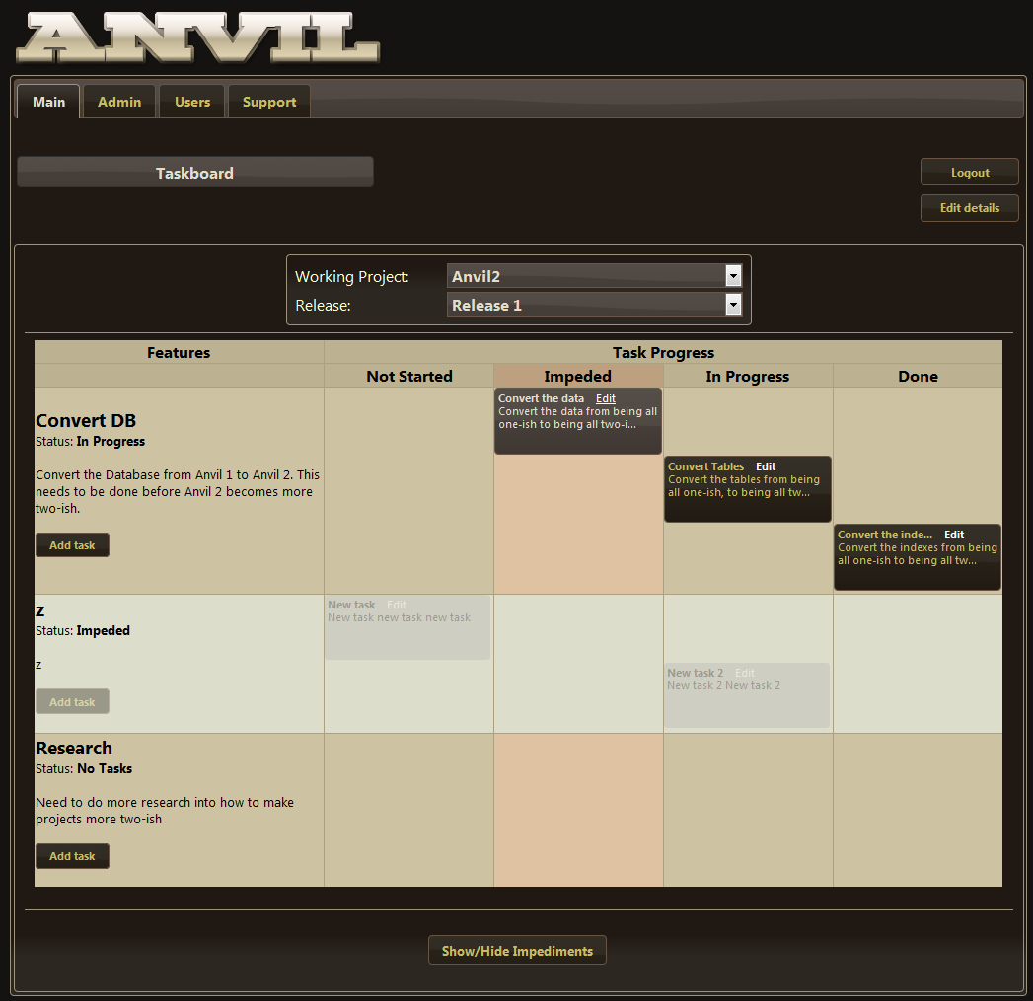

## Selecting Project and release

The “Working Project” and “Release” select boxes are automatically determined using a complicated set of algorithms to try and choose the project and release that your team is currently busy with. You can change the project and release by selecting them from the other options in the list.

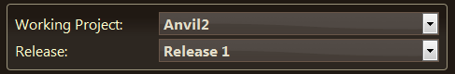

## Drag and dropping tasks

Each task can be dragged and dropped into its new status on the board. Each person viewing this page will get the updates of tasks that are moved on your side. If you have not reloaded the page since someone else has changed the status on a task, a warning will show up, asking if you want to reload the page.

Each task that is assigned to you will be highlighted, and if you hover over the task, it will tell you exactly who is assigned to any of the tasks on the board.

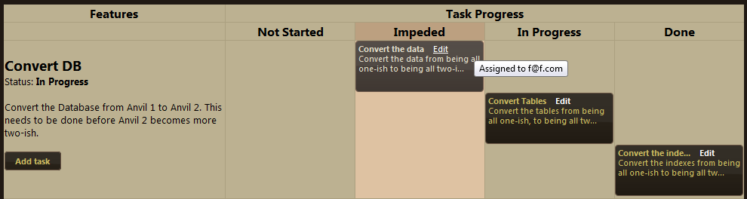

If the feature has been set to *Impeded* by the Company Admin or Team Admin, the tasks cannot be updated, and no tasks can be added from the task board page.

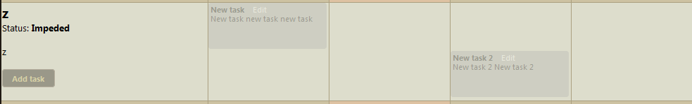

## Adding a task

A task can be added from this page, by clicking on the *Add Task* button contained inside the feature row. The assigned user will be defaulted to you.

## Logout and Edit Details

You can logout of Anvil at any given time by clicking on the *Logout* button.

You can edit your own details at any given time by clicking on the *Edit Details* button.

## Managing impediments

If at any time an impediment pops up that is stopping you from doing your work, it can be added to the Impediments. The team admin should see these impediments and solve them as soon as possible. The impediments can be accessed at the bottom of the task board page by clicking on the *Show/Hide impediments* button.

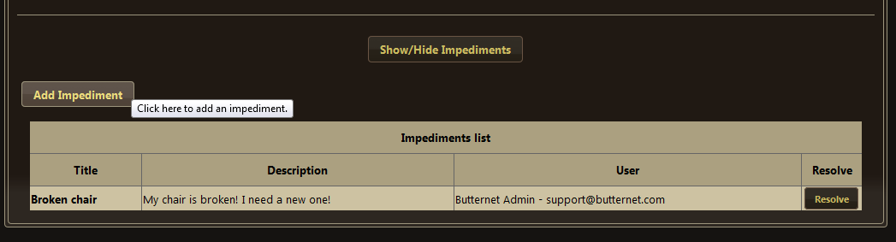

# Using Anvil Support

Anvil prides itself on their customer support. If anything appears to be a bit buggy, or something serious has gone wrong, let us know. Before sending an email to [support@butternet.com](mailto:support@butternet.com), take a look at our support features in the program.

## User documentation

The user documentation for all roles can be downloaded from the *Support* tab, under the sub-tab: *User documentation*. Just by clicking on the PDF Icon of an item in the list, you can download the latest version of the documentation.

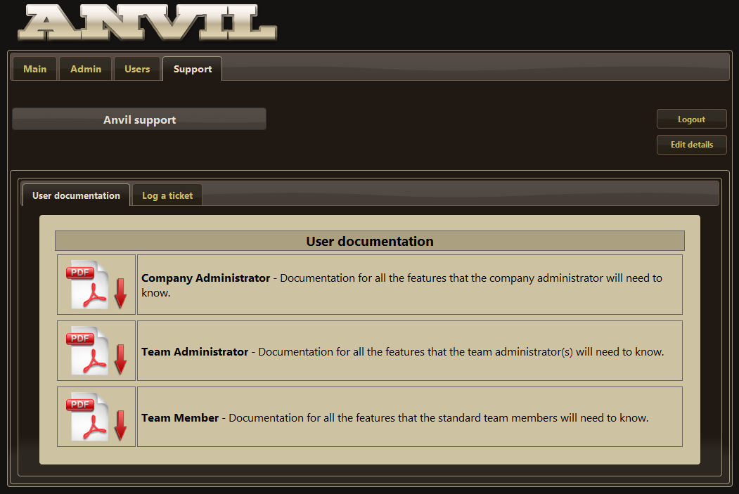

## Logging a ticket

If something is wrong with Anvil, you may log a ticket with our support team. This can be accessed via the *Support* tab, then clicking on the *Log a ticket* sub-tab.

See the following screenshot for an example:  
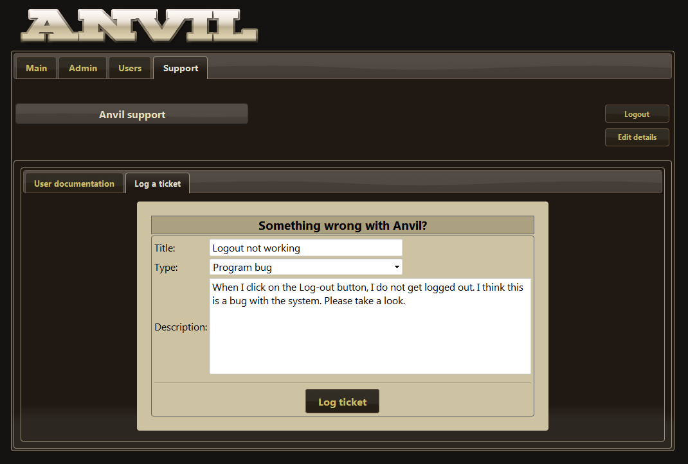

When you have finished filling in your problem, click on the *Log ticket* button. This will send an email to the Anvil Support team. It will also send an auto-respond email to you.

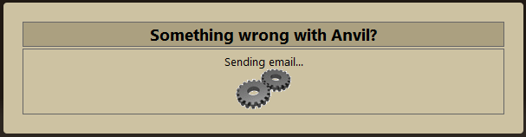

Please do not close the browser or navigate away from the page while it is telling you that the email is sending.